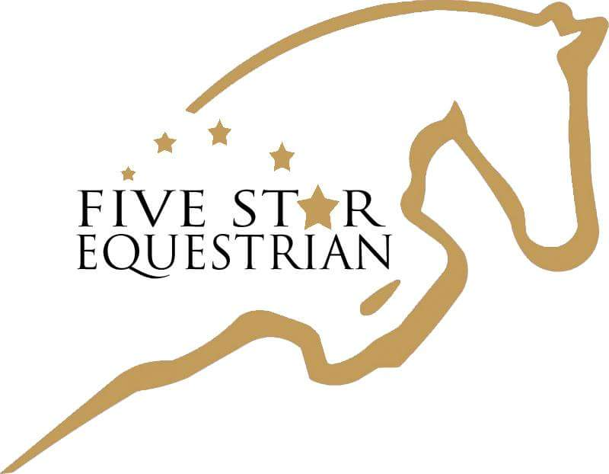

FIVE STAR EQUESTRIAN
Show Equipment List
Item Description | Example
Burgundy Adjusta-Fit® Dura-Nylon® V-Free™ Sheet  https://www.sstack.com/adjusta-fit-dura-nylon-stable-sheets/p/10530w/a1/100000000398/av1/100000007711/a2/100000000521/av2/100000008566/a4/100000000376/av4/100000008676/  “Five Star Equestrian” logo monogram can be added | 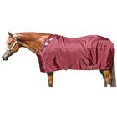
Back on Track Therapeutic Mesh Sheet
https://www.doversaddlery.com/ceramic-mesh-sheet/p/X1-24279B/
Burgundy Dura-Tech® TechoDri® Advanced Fleece Contour Cooler
https://www.sstack.com/dura-tech-tekno-dri-advanced-fleece-contour-cooler/p/38597/

“Five Star Equestrian” logo monogram can be added
2 White Ogilvy Profile Pads for Shows  https://www.smartpakequine.com/pt/ogilvy-profile-pad-11706  OR  2 White Ogilvy Baby Pads for Shows, can also customize with Burgundy boarder  https://www.ogilvyequestrian.com/en/store/product/jump-babypad  “Five Star Equestrian” logo monogram can be added – just purchase and give to Leah | x 2
Hunter Pad
https://www.smartpakequine.com/pt/ecogold-stabilizer-hunter-pad-7389?utm_source=google&utm_medium=cpc&utm_content=NB_Shopping_Catch_All&utm_campaign=Shopping+-+Catch-All&gclid=Cj0KCQiAvbiBBhD-ARIsAGM48bxEH_kD7YkArpmkyXfMN8PEURlM1vl9XYLQF3lr06fbM-rl6OCzaM0aAjYfEALw_wcB&gclsrc=aw.ds
Dura-Tech® No Bow Quick Wraps (2 pairs x 14”)  https://www.sstack.com/dura-tech-quick-no-bow-leg-wraps/p/21061C/ | 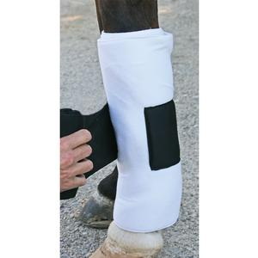
Leather Horse Halter with clip
www.sstack.com (Schneiders)
https://www.doversaddlery.com/circuit-padded-leather-halter/p/X1-05337/

Dura-Tech® 8' Nylon Braided Round Lead  http://www.sstack.com/lead-ropes-shanks/Dura-Tech-8-Nylon-Braided-Round-Lead/ | 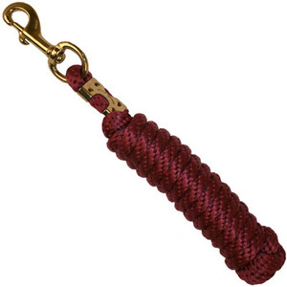
Freedom Feeder Day Net  https://www.bigdweb.com/product/kensington+freedom+feeder+4+flake+day+hay+net+-+2+inch+netting.do?sortby=bestSellers&refType=&from=Search&ecList=6&ecCategory= | 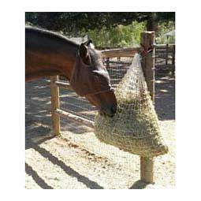
Bandage Sling  Five Star will order from Equitex ($75 + tax)  Color: Tan - Trim: Burguny  “Five Star Equestrian” logo monogram | 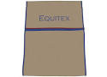
Five Star Equestrian – Equitex Tack Trunk  These tack trunks are special orders through Five Star Equestrian and include name plaques & cover ($1,600)  “Five Star Equestrian” logo monogram | 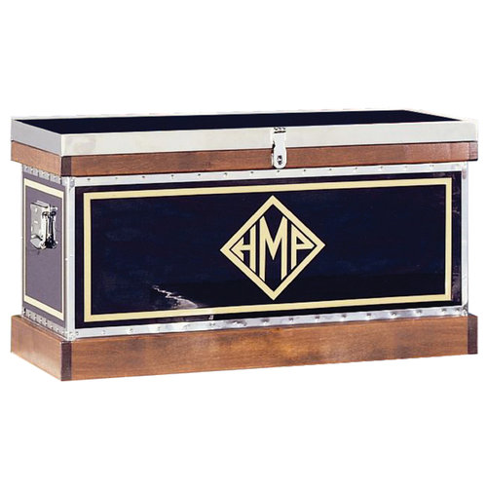
Schooling Girth for Home or Shows
https://www.doversaddlery.com/esstnl-schlng-girth-wsmrtfbrc/p/X1-02683/

MDC Stirrup Irons
https://www.smartpakequine.com/search/search?searchTerm=mdc%20stirrups
See Trainers before purchasing for recommendation or style

Horse Boots
https://www.sstack.com/equine-splint-boots/Eskadron-Horse-Boot-Value-Pack/
If pony, ask trainers about size OR
Equifit Boots (ask trainers about options)
https://equifit.net/
Additional Things to Buy
Schleese Saddle (FSE will set this up)
Leather Girth (Schleese can do bundle with stirrup leathers)
Bridle (some lease horses have bridles)
Standing Martingale, Crop, Spurs
Other Trainer Recommended Equipment
Note: Always check with trainers prior to purchasing any equipment

